S&M CM/166/2G & 3G-Data Plans/11-12/25 dt @ Chennai-6 the 13/07/2011

Sub : Knowing the 3G Data usage through SMS –reg.

The 3G Data customers can get the data usage by sending SMS either from his Data Card or iPAD, if they support SMS facility, or ,from their BSNL / any other Operator mobile numbers by sending SMS, as detailed below:

Instrument from where SMS is to be given. | SMS keyword | SMS to be sent to | Remarks
From DATACARD / IPAD | DATA3G | 53733 | Free
From IPAD | *124*1# | Press call/ Enter button
From BSNL mobile number | DATA3G<space>mobile number of the DATA CARD/ iPAD in 10 digit | 53733 | Free
From mobile number of any operator | DATA3G<space>mobile number of the DATA CARD/ iPAD in 10 digit | 9442253733 | Chargeable as per the customer’s plan with his operator

It may be noted that the customer need not remove the SIM from DataCard/ iPAD and put it in his mobile/ iphone to check the usage

Wide publicity may be given to popularize the facility.
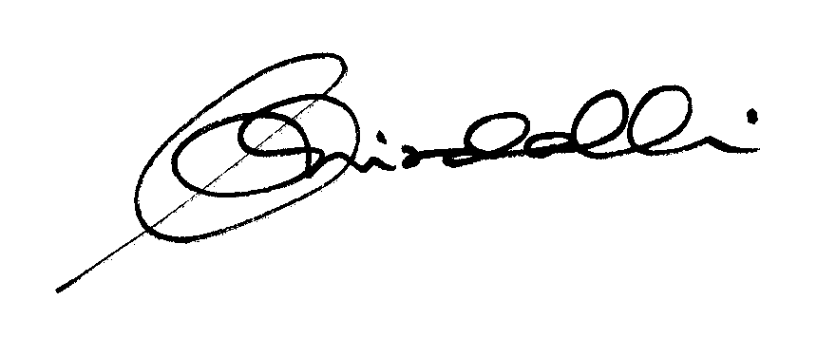

(K.R. Aravindavalli)

AGM(Marketing-CM)

Chennai-6, TN Circle

To
GM (NW-O CM), Trichy -1/ Coimbatore – For information & necessary action please.
GM(S&M-CM), Chennai Telephones, Chennai – for information please.
GM (F) / Sr. GM (TR) TN Circle, Chennai for information please.
DGM In charge IN/DGM Billing & IT – Trichy/Bangalore - for necessary action please.
DGM (N/W-O-CM)/DE Commercial Coimbatore - For information please.
Heads of SSAs, -- for kind information and necessary action please.
DGM (Sales), AGM (Sales) & AGM (MKTG II)- Chennai-6 –For information and informing Sales Heads , franchisee managers and retail managers
DGM (CS), Chennai-6 - For information and informing Call Centre/Customer Service Centre Officials and ensure uploading the information on the website “tamilnadu.bsnl.co.in” .
DGM (S&M-CM)/AGM (MKTG-CM), Chennai Telephones, Chennai – for information & necessary action please.

